M.Abdullah.Mahmood
BCS-3B
22F-3289
DS-LAB 6
To: Sir Abdul Qadeer
Task 1:
#include <iostream>
#include <string>
using namespace std;

class Stack {
public:
int top;
string* arr;
int size;

Stack(int s) : top(-1), size(s) {
arr = new string[s];
}

~Stack() {
delete[] arr;
}

bool isFull() {
return (top == size - 1);
}

bool isEmpty() {
return (top == -1);
}

string peek() {
if (isEmpty()) {
cout << "Stack is empty\n";
return ""; // Return an empty string
}
return arr[top];
}

int sizeOfStack() {
return top;
}

void push(string str) {
if (isFull()) {
cout << "Stack is full\n";
return;
}
top += 1;
arr[top] = str;
}

void pop(string& val) {
if (isEmpty()) {
cout << "Stack is empty\n";
return;
}
val = arr[top];
top -= 1;
}

void push_string(string str) {
string temp;

for (int i = 0; i < str.length(); ++i) {
if (str[i] != ' ') {
temp += str[i]; // Use string concatenation
}
else {
push(temp);
temp = "";
}
}

if (!temp.empty()) {
push(temp);
}
}

void display() {
for (int i = top; i >= 0; --i) { // Start from top
cout << arr[i] << " ";
}
cout << endl; // Print newline to separate from other output
}
};

int main() {
string value;
Stack s(10);
s.push_string("hello i am abdullah");
s.display();
cout << endl;
cout << "undo'ing: \n";
s.pop(value);
cout <<"\t"<< value;
cout << endl;
cout << "top element : ";
cout << s.peek();
cout << endl;
cout << "size of stack starting from 0 : ";
cout << s.sizeOfStack();
return 0;
}

Output:
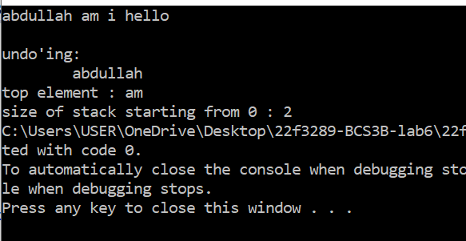

Task 2:
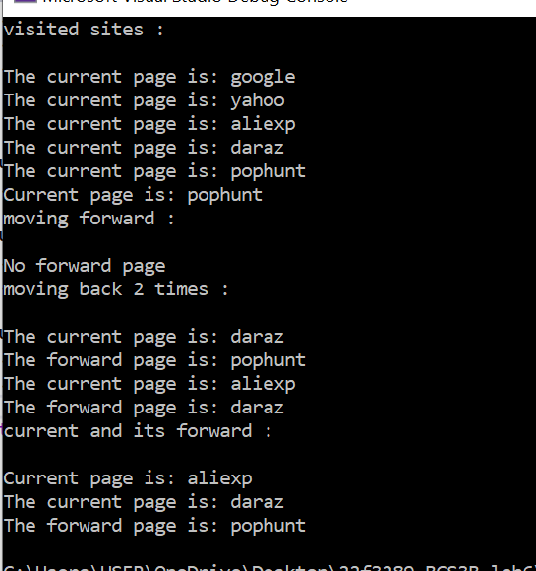

#include <iostream>
using namespace std;

struct Node {
string data;
Node* next;

Node() : data(""), next(nullptr) {}
Node(string d) : data(d), next(nullptr) {}
};

class Stack {
private:
Node* top;

public:
Stack() : top(nullptr) {}

~Stack() {
while (!isEmpty()) {
pop();
}
}

bool isEmpty() {
return (top == nullptr);
}

void push(string value) {
Node* temp = new Node(value);
temp->next = top;
top = temp;
}

void pop() {
if (isEmpty()) {
cout << "Stack is empty\n";
return;
}
Node* temp = top;
top = top->next;
delete temp;
}

string peekAtTop() {
if (isEmpty()) {
cout << "Stack is empty\n";
return "";
}
return top->data;
}

void display() {
Node* temp = top;
if (isEmpty()) {
cout << "Stack is empty\n";
return;
}

while (temp) {
cout << temp->data;
temp = temp->next;
}
}
};

class Browser {
public:
Stack forwardStack, currentStack;

Browser() {}

void visit(string page) {
currentStack.push(page);
forwardStack = Stack(); // Clear forwardStack

cout << "The current page is: " << currentStack.peekAtTop() << endl;
}

void back() {
if (currentStack.isEmpty()) {
cout << "No previous page\n";
return;
}
forwardStack.push(currentStack.peekAtTop());
currentStack.pop();

cout << "The current page is: " << currentStack.peekAtTop() << endl;
cout << "The forward page is: " << forwardStack.peekAtTop() << endl;
}

void forward() {
if (forwardStack.isEmpty()) {
cout << "No forward page\n";
return;
}
currentStack.push(forwardStack.peekAtTop());
forwardStack.pop();

cout << "The current page is: " << currentStack.peekAtTop() << endl;
cout << "The forward page is: " << forwardStack.peekAtTop() << endl;
}

void current() {
cout << "Current page is: " << currentStack.peekAtTop() << endl;
}
};

int main() {
Browser br;
cout << "visited sites : \n\n";
br.visit("google");
br.visit("yahoo");
br.visit("aliexp");
br.visit("daraz");
br.visit("pophunt");

br.current();

cout << "moving forward :\n\n";
br.forward();

cout << "moving back 2 times : \n\n";
br.back();
br.back();

cout << "current and its forward : \n\n";
br.current();
br.forward();

return 0;
}

Task 3:
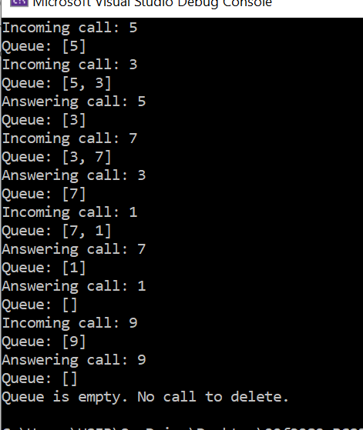

#include <iostream>
using namespace std;

class CircularQueue {
private:
int front, rear, maxSize;
int* queue;

public:
CircularQueue(int size) : front(-1), rear(-1), maxSize(size) {
queue = new int[size];
}

~CircularQueue() {
delete[] queue;
}

bool isEmpty() {
return front == -1;
}

bool isFull() {
return (front == 0 && rear == maxSize - 1) || (front == (rear + 1) % maxSize);
}

void insertCall(int call) {
if (isFull()) {
cout << "Queue is full. Cannot insert call " << call << endl;
return;
}

if (isEmpty()) {
front = rear = 0;
}
else {
rear = (rear + 1) % maxSize;
}

queue[rear] = call;
cout << "Incoming call: " << call << endl;
displayQueue();
}

void deleteCall() {
if (isEmpty()) {
cout << "Queue is empty. No call to delete." << endl;
return;
}

int deletedCall = queue[front];
if (front == rear) {
front = rear = -1;
}
else {
front = (front + 1) % maxSize;
}

cout << "Answering call: " << deletedCall << endl;
displayQueue();
}

void displayQueue() {
cout << "Queue: [";
if (!isEmpty()) {
int i = front;
while (true) {
cout << queue[i];
if (i == rear) {
break;
}
cout << ", ";
i = (i + 1) % maxSize;
}
}
cout << "]" << endl;
}
};

int main() {
CircularQueue queue(5);

queue.insertCall(5);
queue.insertCall(3);
queue.deleteCall();
queue.insertCall(7);
queue.deleteCall();
queue.insertCall(1);
queue.deleteCall();
queue.deleteCall();
queue.insertCall(9);
queue.deleteCall();
queue.deleteCall();

return 0;
}

